# Appendix

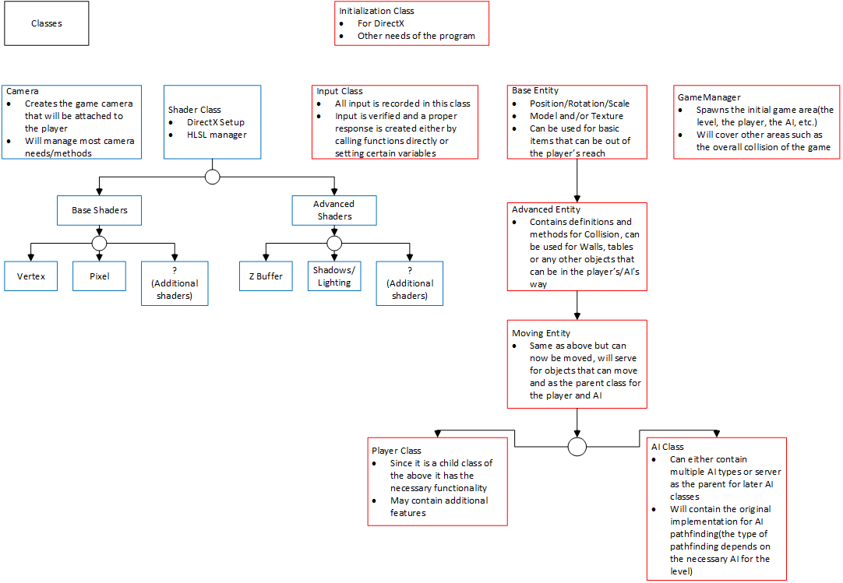

**Figure 2:** Represents the basic view of the team on the game and its classes, with a small view into what each class should do/contain.

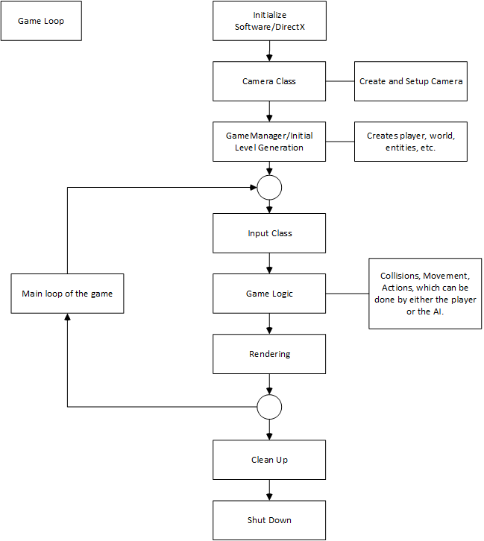

**Figure 3:** Represents the team’s view on how the game loop would work. This contains when certain parts of the engine should happen.

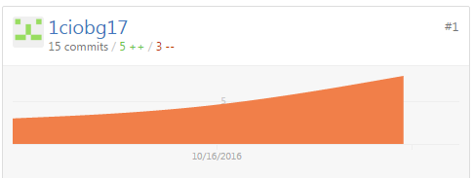

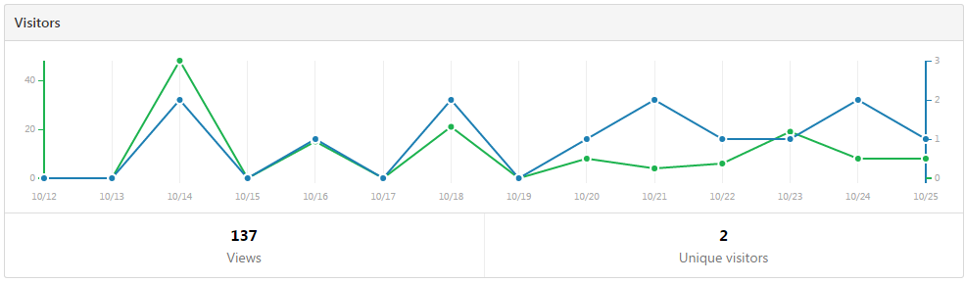

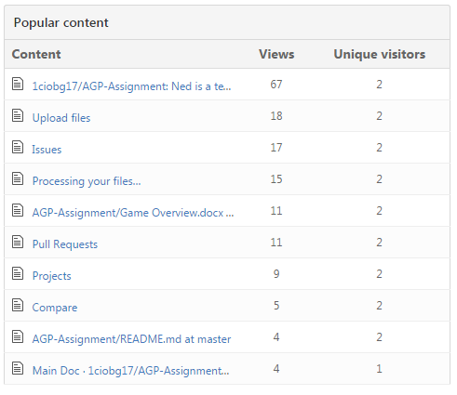

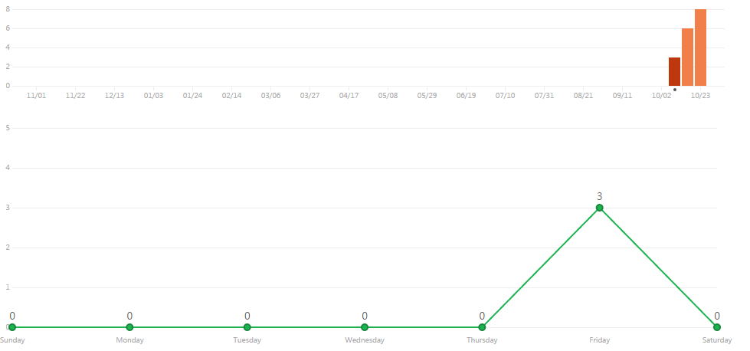

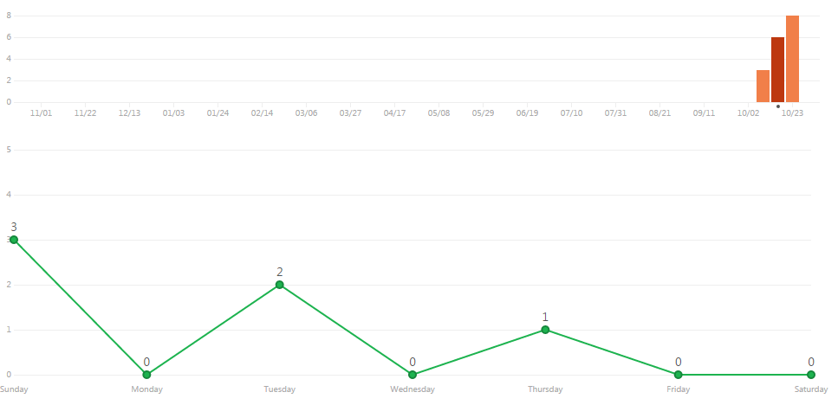

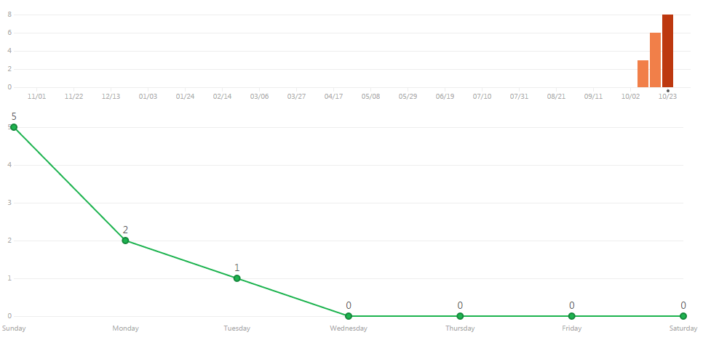

**Figure 4:** These pictures serve as proof for the commits done by team member George Alexandru Ciobanita(Student ID: 1ciobg17).